**Project Design Phase-II**

**Data Flow Diagram & User Stories**

|  |  |
| --- | --- |
| Team ID | PNT2022TMID36299 |
| Project Name | Project - AI-powered Nutrition Analyzer for Fitness Enthusiasts |
| Maximum Marks | 4Marks |

**Data Flow Diagrams:**

A Data Flow Diagram (DFD) is a traditional visual representation of the information flows within a system. A neat and clear DFD can depict the right amount of the system requirement graphically. It shows how data enters and leaves the system, what changes the information, and where data is stored.

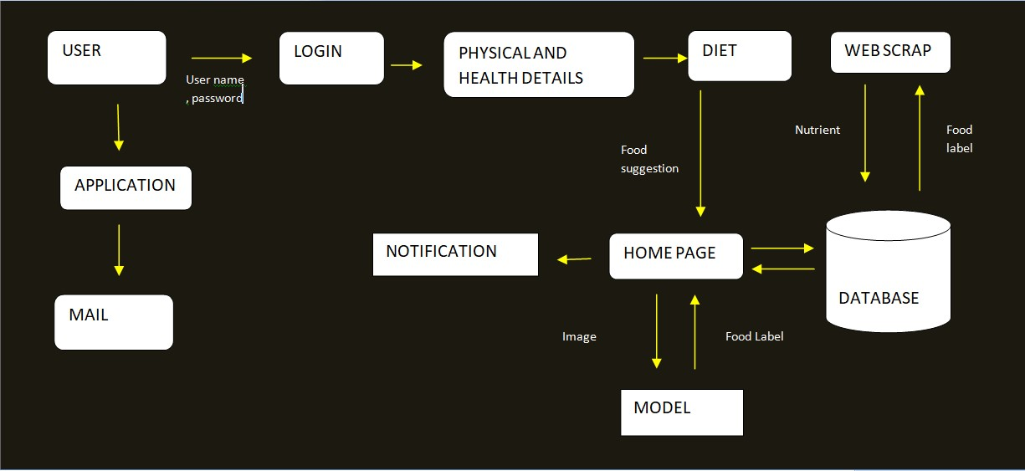

**User Stories**

Use the below template to list all the user stories for the product.

|  |  |  |  |  |  |  |
| --- | --- | --- | --- | --- | --- | --- |
| **User Type** | **Functional**  **Requirement**  **(Epic)** | **User Story Number** | **User Story / Task** | **Acceptance criteria** | **Priority** | **Release** |
| Customer  (Mobile user) | Registration | USN-1 | As a user, I can register for the application by entering my email, password, and confirming my password. | I can access my account / dashboard | High | Sprint-1 |
|  |  | USN-2 | As a user, I will receive confirmation email once I have registered for the application | I can receive confirmation email & click confirm | High | Sprint-1 |
|  |  | USN-3 | As a user, I can register for the application through Facebook | I can register & access the dashboard with Facebook  Login | Low | Sprint-2 |
|  |  | USN-4 | As a user, I can register for the application through Gmail |  | Medium | Sprint-1 |
|  | Login | USN-5 | As a user, I can log into the application by entering email & password |  | High | Sprint-1 |
|  | Dashboard | USN-6 | Not Required |  | Medium | Sprint-2 |
| Customer (Web user) | Data Setup | USN-7 | As a User, I will enter my Data’s which includes Height, Weight, Age & Gender .. | I can include the data contents in the application | High | Sprint-2 |
| Customer Care Executive | Queries | USN-8 | As a User, I can raise and submit their queries in the Q&A section | I can raise the queries how to use the application in Q&A. | Medium | Sprint-1 |
| Administrator | Diet Chart | USN-9 | User can customize the Diet chart based upon their Maintenance calorie. | I can customise the diet chart. | High | Sprint-2 |
|  | Liquid Intake | USN-10 | User can add the amount water they consume and get the hourly remainder to consume water | I can get the hourly remainder to consume water  . | Medium | Sprint-1 |
|  | Workout | USN-11 | I can add the customized workout to do on the daily basis. | I can the daily workout session. | High | Sprint-1 |
|  | Community Chart | USN-12 | User can create a community and chat with them accordingly | I can interact with other users. | Medium | Sprint-2 |